- Copyright for test papers and marking guides remains with West Australian Test Papers.
- The papers may only be reproduced within the purchasing school according to the advertised conditions of sale.
- Test papers must be withdrawn after use and stored securely in the school until Wednesday 5th December 2012.

PHYSICS

YEAR 11

STAGE 2B

2012



SOLUTIONS

Section A 80 marks = 40%
Question 1
a) The refrigerator uses the principle of latent heat of vaporisation to cool the inside cabinet and its contents and is insulated to minimise heat transfer between the inside and the outside. A refrigerant is circulated through pipes in the refrigerator walls and is alternatively compressed and expanded so latent heat of vaporisation is extracted from the inside of the cabinet in the process thus cooling the contents (bottle of water) (3 marks)
b) As the thermostat in the refrigerator is set at 4 ºC, the temperature in the cabinet will not fall below that temperature. As water freezes at 0 ºC, the water will remain in the liquid phase.
(1 mark)
Question 2
a) A kilowatt hour is a unit used for calculating and costing energy consumption.
A watt is a joule per second. So the dimensions are energy / time. When these dimensions are multiplied by hours, (that is time), the result is energy.
[energy / time) x time] is equivalent to energy. (2 marks)
b) Assumption: Student uses the lamp for 3 hours per day for 5 days per week
Cost of electricity is 20 cents per kWh
Calculation:
40 x 5 x 3 = 600 h
(15/ 1000) x 600 = 9 kWh
Cost is 9 x 20 = 180 cents = $1.80 (3 marks)

Question 3
a) The filament is a non ohmic conductor that has a high resistance. It is this high resistance that causes the electrical energy to be converted into heat and light. The conducting wires are ohmic resistors and have a relatively low resistance that allows electrical energy to be conducted with only a small quantity of energy being lost in the process. (2 marks)
b) Compact fluoro globes are more environmentally friendly because they use a different technology to incandescent globes, which makes them capable of converting electrical energy into light energy more efficiently. Less energy is lost to heat (they run cooler) and they are cost effective because they have a life time many times greater than an equivalent incandescent globe. (2 marks)
Question 4
A dimmer is essentially a variable resistor. As the resistance in a circuit is changed so the current is altered and the quantity of energy being delivered to lights is either increased (lights are brighter) or reduced (lights dim). The dimmer, which is usually in series with the light to be affected, is operated by knob or lever that changes the resistance in the circuit. (3 marks)

Question 5
- The brick itself is a good insulator plus the air cavity between the double brick construction adds to the insulation properties. Minimising heat transfer through the wall by conduction and convection. (1 mark)

b) Double glazing consists of air (or a vacuum) trapped between two sheets of glass. Although some heat transfer occurs in the glass. The air, being a poor conductor minimises heat transfer between the two sheets of glass. (1 mark)
c) A doona is usually filled with down, feathers or polyester, all of which are good insulators. In addition the doona traps a large quantity of air between the “fill” component. This minimises heat transfer by conduction from the top to the underneath of the doona. (1 mark)
d) Carpet is usually made of wool or synthetic fibre which are good insulators. When trodden upon there is little heat transfer by conduction between the person’s feet and the carpet. (1 mark)
Question 6
a) Resistance in the parallel circuit 1/R_{T} = 1/R₁ + 1/R₂
1/R_{T} = 1/8 + 1/32 so 1/R_{T} = 5/32
so R_{T} = 32/5 = 6.4 Ω
Total resistance in the series circuit = R_{T} + R₁ + R₂ + R₃
R_{T} = 16 + 20 + 6.4 = 42.4 Ω (3 marks)
b) The 16 Ω and 20 Ω resistors will both carry the same current which will be greater than the currents carried by either the 8 Ω or 32 Ω resistors.
In a series circuit all resistors carry the same current. Because the 8 Ω and 32 Ω resistors are in parallel they will carry only proportions of the total current. (2 marks)
Question 7
a) Western Australia receives a large proportion of solar energy compared to other parts of the world. The climate (long summers with clear skies) means solar hot water systems receive an adequate exposure to sunlight to sustain their use economically. (2 marks)
b) Rate of absorption of energy = 1700 J s⁻¹
In 45 min energy absorbed = 1700 x (45 x 60) = 4.59 x 10⁶ J
To calculate rise in temperature of water.
Q = m c ΔT
4.5 x 10⁶ = 17 x 4180 x ΔT
ΔT = 64.6 Cº (3 marks)

c) The major assumption is that the water is not circulating. In reality the water would be circulating in the heater due to convection currents. This would alter the rate of heating.
(2 marks)
Question 8
a) An ammeter measures current and is connected in series with the circuit it is measuring. By having little resistance all the current in the circuit passes through the meter so giving an accurate measurement of the current. If the ammeter had a high resistance, it would reduce the current and therefore give an inaccurate reading. (2 marks)
b) A voltmeter measures potential difference in a circuit and is connected in parallel with the component it is to measure. It has a high resistance so only a small proportion of the current passes through it. The potential drop across the component it is measuring can be measured without impacting on the intended purpose of the circuit. (2 marks)
Question 9
a) The greater surface area that is exposed to the air when clothes are hung on a line allows increased evaporation of the water content. Air movement removes moist air from the surface of the clothes, facilitating further evaporation.
When clothes are left crumpled with reduced surface area exposed to the air evaporation of the water content is restricted and so the clothes take longer to dry. (2 marks)
b) In humid conditions the air surrounding the wet clothes would contain more water vapour than under non-humid conditions. Therefore the rate of evaporation from the wet clothes would be reduced because less vapour could enter the adjacent air. In extreme humidity, when the air was saturated with vapour the clothes would take longer to dry. (2 marks)
c) Air movement. (The reason: If air is circulating around the wet clothes then moist air is removed from the vicinity of the clothes and “drier” air takes its place. The drier air is capable of holding more moisture than the moist air so the rate of evaporation is increased.) (1 mark)
Question 10
Conduction of heat involves the particles (atoms and molecules) of a substance vibrating and transferring energy from one particle to another. The transfer is from particles containing higher energy to particles containing lesser amounts of energy. (3 marks)
Question 11
a)
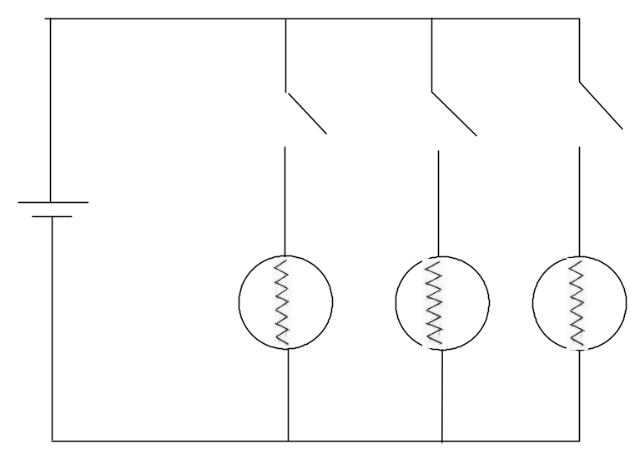 (4 marks)
b) The remaining lamps would still operate. Because the current is divided between the lamps in a parallel circuit, there would still be a current flowing in the other two branches, sufficient to keep the lamps operating. (2 marks)

Question 12
a) Heat loss by ice = Heat gain by water
(m x L) + m c ΔT = m c ΔT
(m x 3.34 x10⁵) + (m x 4180 x 5) = (0.75 x 4180 x 17)
3.34x10⁵ m + 20 900 m = 53 295
3.549 x 105 m = 53 295
m = 53 295 / 3.549 x 10⁵ = 0.150 kg (4 marks)
b) Add the ice to the water in the largest pieces possible. The larger pieces, because of their larger surface are, melt more slowly and hence maintain the water at a colder temperature for longer. (2 marks)
Question 13
a) To change the temperature of 5.0 g from 25 ºC to 100 ºC
Q = m c ΔT
Q = 0.005 x 4180 x 75 = 1.57 x 10 ³ J (3 marks)
b) To convert the water into steam
Q = m x L = 0.005 x (2.26 x 10⁶) = 1.13 x 10⁴ J (2 marks)
c) Total energy required = 1567.5 + (1.13 x 10⁴) =12 867.5 J
P = V²/R
P = 240² / 50 = 1152 W
P = E/t so t = E/P = 12 867.5 / 1152 = 11.2 seconds (4 marks)
Question 14
a) By placing resistors in strategic positions across components, the quantity of current that a component requires to operate can be regulated. For instance a radio that only requires 0.5 A of current can be placed in parallel with a resistor that allows the greater proportion of the current to be diverted around the radio. On the other hand a headlight that requires 5 A would require a resistor of a smaller value to be placed in parallel with it.
A second way of directing the correct current to components is to connect them to transformers that are capable of stepping up or stepping down voltages and currents.
A third way of regulating current to components is to place resistors in series with the component thus changing the current that flows through it. (3 marks)

b) P = V I
65 = 12 x I so current is 5.42 A (2 marks)
c) P = V I
65 = 12 x I so the current is 65/12 = 5.42 A
Energy = V I t = 12 x 5.42 x (45 x 60) = 1.76 x 10⁵ J (2 marks)

d) P = I² x R
65 =5.42² x R
R = 65 / 5.42² = 2.21 Ω (2 marks)
Question 15
If the circuit is fitted with an electronic circuit breaking device that detects a minute imbalance in current between the active and neutral wires then the electricity to the washing machine circuit will be cut off the instant the person touches the casing, thus saving the person from an electric shock. (3 marks)
If the circuit breaker is not installed or is not operating properly then some of the current will flow, through the person touching the casing, to earth and in the process will provide the person with an electric shock. Most current will flow to earth through the earth wire. (3 marks)

END OF SECTION A
Section B 100 marks = 50%
Question 1
a) Q _{water} = m c ΔT = 0.75 x 4180 x 80 = 250 800 J
Q _{glass} = m x c x ΔT = 0.3 x 840 x 90 = 22 680 J
Total heat absorbed = 250 800 + 22 680 = 273 480 J
= 2.73 x 10⁵ J (5 marks)
b) Oven uses 800 W for 6 min 50 s
Energy used by the oven = 800 x {(6 x 60) + 50} = 328 000 J
= 3.28 x 10⁵ J (3 marks)

c) Efficiency = {(energy input – energy output) / energy input} x 100
% loss of energy = {(328000 – 273 480) / 328000} x 100 = 16.6%
This means the oven is 83% efficient (5 marks)
d) The claim that the microwave oven is 85% efficient is reasonable considering the status of the experiment conducted to verify the claim. The errors incurred by students in the school based experiment would account for the difference in the stated efficiency and the experimental value. The student’s calculated value would be within the limits of experimental error. (2 marks)
Question 2
a) (5 marks)
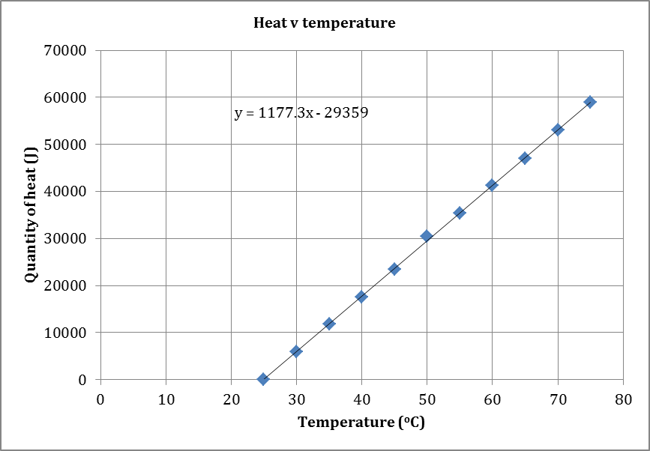
b)
Q = m x c x ΔT
c = (Q / ΔT) x 1/m = gradient of graph x 1/m
c = 1177 x 1 / 0.5 = 2354 J K⁻¹ kg⁻¹
c = 2.35 x 10³ J K⁻¹ kg⁻¹ (5 marks)
c)
The result calculated by the students is closest to the specific heat of ethanol
(c = 2.44 x 10³ J K⁻¹ kg⁻¹)
When an experimental error of 3.7% is considered, this represents a reasonable result.
(2 marks)

Question 3
a) Select from the following controls
Same quantity of cotton wool
Same quantity of liquid in each cotton wool
Equal starting temperatures
Equal time exposed to the air
Equal surrounding conditions (air flow etc)
Same type of thermometer (4 marks)

b) While the saturated cotton wool on both thermometers was exposed to the air some of the liquid would have evaporated. In doing so energy would have been drawn from the thermometer bulbs thus causing a drop in temperature. (3 marks)
c) There were two different liquids involved. It was possible that the two liquids had different values for their latent heat of vaporisation. If the values were different then different amounts of evaporation would have occurred and different quantities of heat would have been drawn from the thermometer bulbs causing a difference in temperatures. (2 marks)
d) The concept of latent heat of vaporisation was being demonstrated and different liquids have different latent heat values. Evaporation rates and volatility of different liquids may have been other concepts the teacher was trying to demonstrate. (1 mark)

Question 4
a) Resistance in the BC parallel circuit:
1/R_{BC} = 1/R₁ + 1/R₂ + 1/R₃
1/R_{BC} = 1/10 + 1/15 = 5/30 so R_{BC} = 6 ohms

Resistance in he CD circuit:
1/R_{CD} = 1/R₁ + 1/R₂ + 1/R₃
1/R_{CD} = 1/30 + 1/18 + 1/9 = 18/90 so R_{CD} = 5 ohms

Total resistance in the circuit is 4 Ω + 6 Ω + 5 Ω = 15 Ω (3 marks)

b) V = I R
120 = I x 15
Current (I) is 120/15 = 8.0 A (2 marks)

c) V = I x R
V = 8.0 x 4 = 32.0 V (2 marks)
d) The answer is B (1 mark)
e) Current in a series circuit is equal in all parts of the circuit. Only when the current is divided when it is in a parallel part of the circuit will it have a different value. (2 marks)
f) q = I t
q = 8.0 x 120 = 960 C =9.60 x 10² C (2 marks)
g) 1.5 MJ
E = V I t
1.5 x 10⁶ = 120 x 8 x t
t = 1.5 x 10⁶ / (120 x 8) = 1562.5 seconds
Time = 1562.5 s = 26.0 minutes (3 marks)
Question 5
a) Heat lost by steam = Heat gained by water.
(m L) + (m c ΔT) = m c ΔT
(0.022 x L) + 0.022 x 4180 x 20 = 0.205 x 4180 x 59
L = [(0.205 x 4180 x 59) – (0.022 x 4180 x 20)] / 0.022
L = 2.21 x 10⁶ J kg⁻¹ (4 marks)

b) {(2.26 x 10⁶) – (2.21 x 10⁶) / (2.26 x 10⁶)} x 100 = 2.04 % (2 marks)
c) Yes. This is a very, very good result using the equipment supplied. Any percentage error less than 5% in these circumstances would be acceptable. (2 marks)
d) The long delivery tube could cause steam to condense in the tube so water, not steam, may enter the styrofoam cup thus producing an error in the calculation. (2 marks)
Question 6
a) A and B (1 mark)
b) C (1 mark)
c) A and B (1 mark)
d) 1/R_{T} = 1/R₁ + 1/R₂ + 1/R₃
1/R_{T} = 1/10 + 1/20 + 1/30 = 11/60
So resistance in the parallel circuit is 60/11 = 5.45 Ω
Total resistance in the circuit = 5.45 + 40 = 45.45
To calculate total current (I) V = I R
24 = I x 45.45
I = 24 / 45.45 = 0.528 A
PD across 40 Ω resistor = IR = 0.528 x 40 = 21.12 V
PD across the parallel resistors = 24 – 21.12 = 2.88 V
So current in the 30 Ω resistor = V/R = 2.88/30 = 0.096 A (6 marks)
e) Meter E will measure the potential difference across the 40 Ω resistor.
V = I R = 0.528 x 40 = 21.12 V (2 marks)
f) No. the current will be the same no matter where it is measured. The electrons drift through the circuit and as there is only one path for them to take, they drift at the same rate in all parts of the circuit. (2 marks)
g) In a parallel circuit the current divides in a ratio determined by the size of the parallel resistors. The greater the resistance, the smaller the current. The sum of the individual currents in the parallel circuit is equal to the total current in the circuit.
That is: Total current in equals total current out. (2 marks)

Question 7
a) During this time the substance is undergoing a phase change. Energy that is absorbed by the substance is being used to break bonds that exist between molecules/atoms of the solid. Therefore there is no rise in temperature until all the substance has changed phase. (1 mark)
b) -39 ºC (1 mark)
c) 357 ºC (1 mark)
d) 1.26 x 10⁴ J kg⁻¹ (2 marks)
e) 2.85 x 10⁵ J kg⁻¹ (2 marks)
f) No. The substance is not water. The two values, latent heat of fusion and latent heat of vaporisation, do not agree with the accepted corresponding values for water. (1 mark)
Question 8
a) When the plastic is rubbed electrons are transferred from the cloth to the rod and accumulate at the point where it was in contact with the cloth producing a negatively charged rod. Because he rod is an insulator the electrons do not move along the rod. The cloth, having lost electrons, becomes positively charged. (2 marks)
b) The paper, being at a neutral potential with respect to the negatively charged rod, is attracted to the rod because of the difference in potential. (2 marks)
c) After some time the electrons that have accumulated on the rod drift to the paper. When the potential of the rod and paper are equal, there is no more attractive force so the paper falls away from the paper. (2 marks)
d) Copper is a good conductor so if electrons are transferred to the rod they are conducted along the rod and to earth so no charge accumulates. (2 marks)
e)
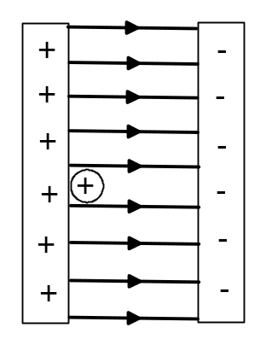 (2 marks)
f) q = 1.60 × 10⁻¹⁹ C V = 12.0 V m_{proton} = 1.67 × 10⁻²⁷ kg (data sheet)
KE_{initial} = 0 KE_{final} = ½ m v²
(use absolute value of charge as v is scalar)
W = q.V = ΔKE = KE_{final} - KE_{initial}
q.V = ½ m v²
1.60 × 10⁻¹⁹ × 12.0 = ½ × 1.67 × 10⁻²⁷ × v²
v² = 22.994 × 10⁸ so
v = 4.80 × 10⁴ m s⁻¹ (5 marks)

END OF SECTION B

Section C - 20 marks = 10%
Question 1 (7 marks)
- Grounded means the device is earthed. That is there is a connection to the Earth through a conductor. (1 mark)

- The item needs to be grounded to complete the circuit so a potential is created between the powder and the item being coated. (2 marks)

- No. It would not matter what charge is on the powder particles. As the item to be coated is at a neutral potential both positive and negative particles would be attracted to the item. (2 marks)

- Plastic is an insulator and therefore cannot carry an electric current so cannot be grounded to create the potential necessary to attract the charged powder particles. (1 mark)

- Both steel pergola frames and metal furniture can be grounded and a neutral potential created. This provides the electrostatic force that attracts the powder particles. (1 mark)
Question 2 (13 marks)
- A rate of 915.0 kJ s⁻¹ (1 mark)

- Calculate the mass of water required per second to replenish the heat lost if the heat exchanger is 100% efficient.
Q = m c ΔT
915 000 = m x 4180 x (41 – 26)
m = 915 000 / (4180 x 15) = 14.6 kg which equates to 14.6 L per second
However the heat exchanger is only 90% efficient so the rate needs to be 10% greater.
10% of 14.6 L s⁻¹ is 1.46 L s⁻¹
The pump rate is therefore 14.6 + 1.46 = 16.1 L s⁻¹ (6 marks)

- When the water evaporates from the surface of the pool it absorbs latent heat of vaporisation from the water thus having a cooling effect. (2 marks)
- No. The rate of cooling of the pool water will not be constant due to various weather factors that occur during a 24 hour cycle. Temperature, air movement (wind), humidity, patron use are some of the factors that will impact on the loss of heat energy from the pool. Automatic pumping mechanisms are likely to be in place to cater for the different rates of heat loss. (2 marks)

- Conduction to the pool structure, radiation from the surface, convection as air above the pool circulates, water loss due to splashing and agitation by patrons of the pool water are all additional factors that would contribute to energy loss. (2 marks)

END OF EXAM SOLUTIONS

